Slovenia and some of its superlatives

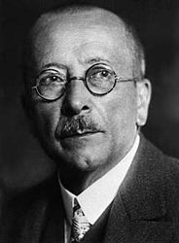
- The first and only Slovenian Nobel laureat is Friderik Pregl. He won the Nobel Prize in Chemistry in 1923.

- The heaviest Carniolian Sausage was 520 kg heavy and 4 meters long. It was produced in 1999 by the butcher’s Arva.
- The first Slovenian cookery book was written by Magdalene Pleisweis in 1868.
- The deepest cave is the Škocijan cave. It’s 250 m deep.
- The highest waterfall in Slovenia is Waterfall Čedca; It’s 132 meters high.
- The highest building in Slovenia is the chimney of Thermo power plant Trbovlje. It's 360 m high, which means it is higher than the Eiffel Tower.
- The highest skyscraper is the World Trade Center Ljubljana ; it’s 75 meters high.
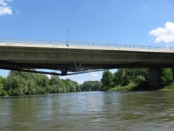
- The longest road bridge is the bridge crossing the river Mura; it’s 833 m long.
- The oldest and the largest golf course in Slovenia is the golf course Bled.
- The longest tunnel is the tunnel Karavanke - 8019 m (203 m on Slovenian side)
- The first Slovene film to win an oscar was the film '' No Man's Land'' in 2001.
- The first Slovene colour film was Kekec, directed by Jože Gale.
- The oldest whistle in world was found in the cave ‘’Divje babe’’. It's 45.000 years old and it's made from the bone of a cave bear.
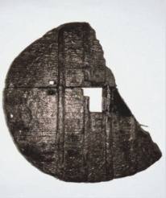
- The oldest wheel in world was found in the Ljubljana marshes; the wheel is more than 5000 years old .
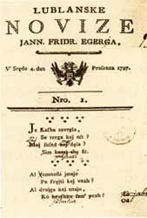
- The first skiis in Elan were produced in 1945.
- The first Slovenian newspaper was ‘’Lublanske novice.’’

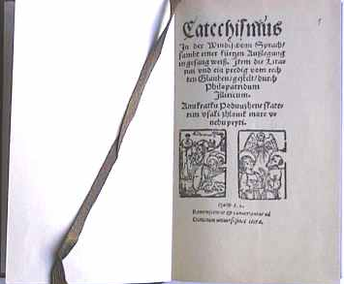
- The oldest books in Slovenia are Abecednik and Katekizmus. They were written by Primož Trubar in 1550.

- The most common trees in Slovenia are beech and pine trees.
- The first Slovenian flight pioneer was Edward Rusjan. He made his first flight in 1909. The airport in Maribor is named after him.
- The first Slovene couple that reached the peak of the Mount Everest were Marija and Andrej Štrempelj.
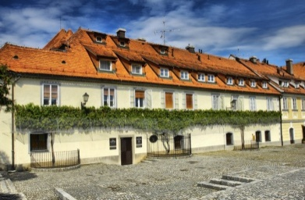
- The oldest Slovene grapevine is in Maribor. It is about 440 years old. It is recorded in the Guinness Book of Records as the oldest grapevine in the world.

- The most unique living creature is a proteus, which lives in the karst caves.

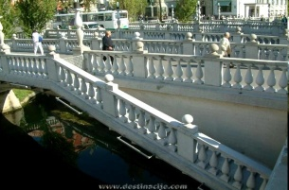
- The most famous Slovene bridge is Tromostovje (The Three Bridges) crossing the river Ljubljanica that flows through Ljubljana.

- The most popular instrument among the Slovenes is an accordion.
- The longest cave system in Slovenia is Postojna cave. It is about 20 km long cave system created by Pivka river.
- The greatest Slovene poet is France Prešeren. He wrote Zdravljica . Its 7 th stanza is the Slovene anthem.
- The most popular brands among the Slovenes are Barilla, Nutella, Dr. Oetker, Samsung, Nivea, Adidas, …
- The most appreciated among laptops is Apple's.
- Currently, the most popular folk music performers are Modrijani.
- Vrtoglavica cave holds the record for having the deepest single vertical drop (pitch) of any cave on Earth, at a depth of 603 metres (1,978 ft). 603 m long rope can freely hang inside this cave.

The superlatives are discussed with the 7th graders of Elementary School Dragomelj
the results of the first Slovenian QUDAL - QUality meDAL - DEEPMA Research conducted in March 2014 by the Swiss organization ICERTIAS - International Certification Association GmbH with its headquarters in Zurich by means of an online survey on a sample of 1,200 Slovenian citizens, Internet users older than 15 years of age.

