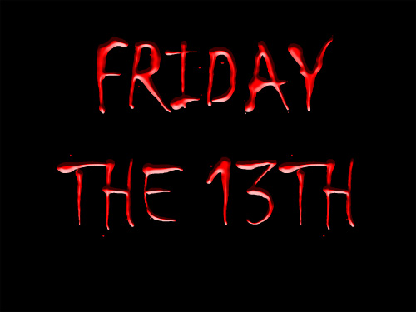
Unlucky day
- Every year has at least one Friday 13th and at most three. In 2017 Friday the 13th occurs twice – in January and October!
- The fear of Friday the 13th is friggatriskaidekaphobia (after Frigga, the goddess who gave her name to Friday).
- Mediaeval Christians thought Friday unlucky as the day of the crucifixion, and 13 has been thought unlucky since pre-Christian times.
- Many people change their behaviour on Friday the 13th, for example, they won't leave their house, they don't go to work, they don't shop, they don't eat out,…
- Many hospitals don’t have a room number with 13 in it as well as a 13thfloor. The same thing goes for some hotels. Normally the 13th floor is skipped. Some airlines omit Gate 13.
- President Franklin D. Roosevelt would never have a 13th guest at a meal, nor would he travel on the 13th day of any month.
- Taylor Swift considers 13 her lucky number and used to paint 13 on her hand.
- The Athens Olympic Games opened on Friday 13th of August, 2004.
- The movie “Alive” is based on the true story of a plane crash in South America on Friday, October 13th, 1972. 14 survivors were found in the mountains more than two months after the plane went down.

Good luck charms or bad omens?
- A ladybug and a four-leaf clover are believed to bring good luck.
- If you see a black cat crossing the road something bad might happen.
- If you open an umbrella indoors you will have bad luck.
- If you break a mirror you will have 7 years of bad luck or misfortune.
- If you walk under a ladder you will have bad luck.
- Spilling salt is believed to bring bad luck.
- If you see a chimneysweep and you touch your button you will have good luck.
- You will have good luck if you manage to find a horseshoe (which is highly unlikely today.:) )
- If you see a shooting star your wish may come true.
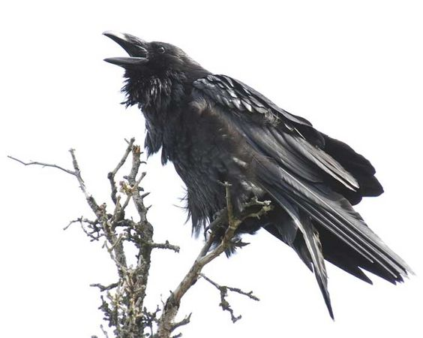
- Keeping fingers crossed for someone may bring him / her good luck .
- Ravens are believed to be birds of evil omen.
- If you throw a coin into a wishing well, your wishes may come true.

Discussed with the 7th graders

