What do they have in common?
A robin and a peacock?
A salamander and a crocodile?
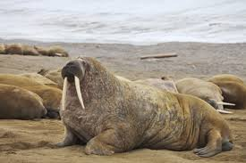
A woodpecker and a toucan?
A viper and a vampire bat?
A dragon fly and a hawk?
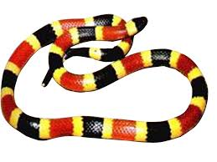
An elephant and a walrus?
A squid and a jellyfish?
A zebra and a coral snake?
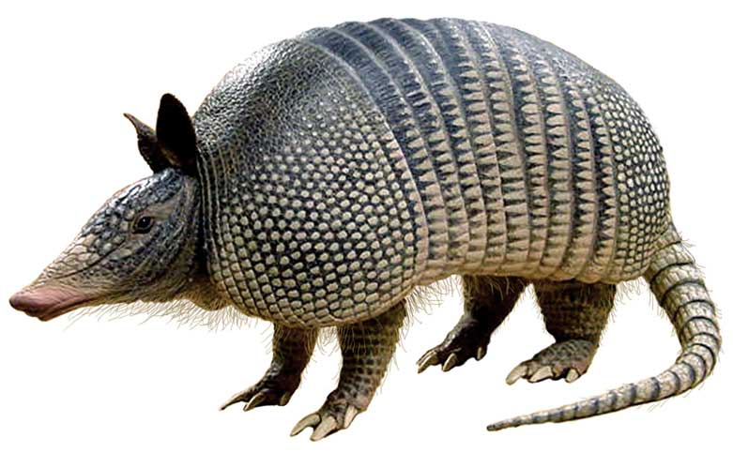
A leopard and a dalmation?
A snail and an armadillo?
A jaguar and a siamese cat?
A fish and a rattle snake?
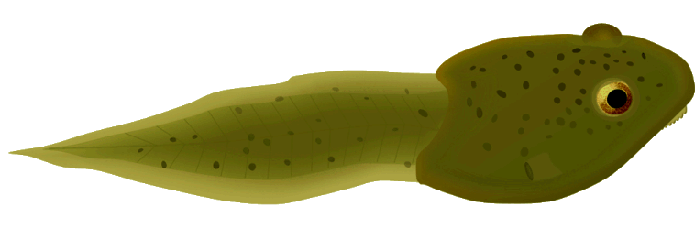
A bull and an antelope?
A horse and a gazelle?
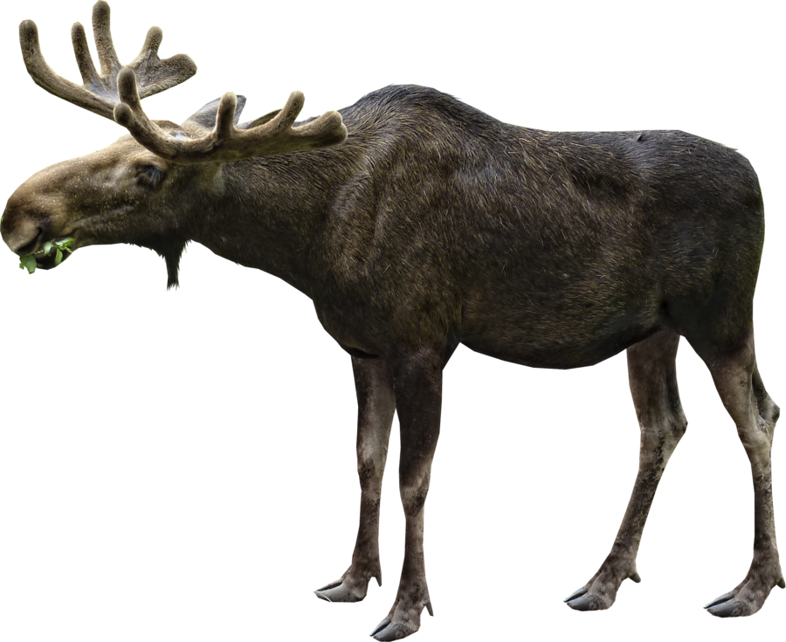
A great white shark and a tadpole?
A deer and a moose?
A crab and a lobster?
A shark and a dolphin?
A beaver and a polar bear?

KEY:
What do they have in common?
a robin and a peacock? – feathers
A salamander and a crocodile? – a tail
A woodpecker and a toucan? – a beak
A viper and a vampire bat? - fangs
A dragon fly and a hawk? - wings
An elephant and a walrus? - tusks
A squid and a jellyfish? - tentacles
A zebra and a coral snake? - stripes
A leopard and a dalmation? - spots
A snail and an armadillo? – a shell
A jaguar and a siamese cat? - paws
A fish and a rattle snake? - scales
A bull and an antelope? - horns
A horse and a gazelle? - hooves
A great white shark and a tadpole? – gills
A deer and a moose? - antlers
A crab and a lobster? – claws
A shark and a dolphin? - fins
A beaver and a polar bear? – fur

