Facts about the human brain
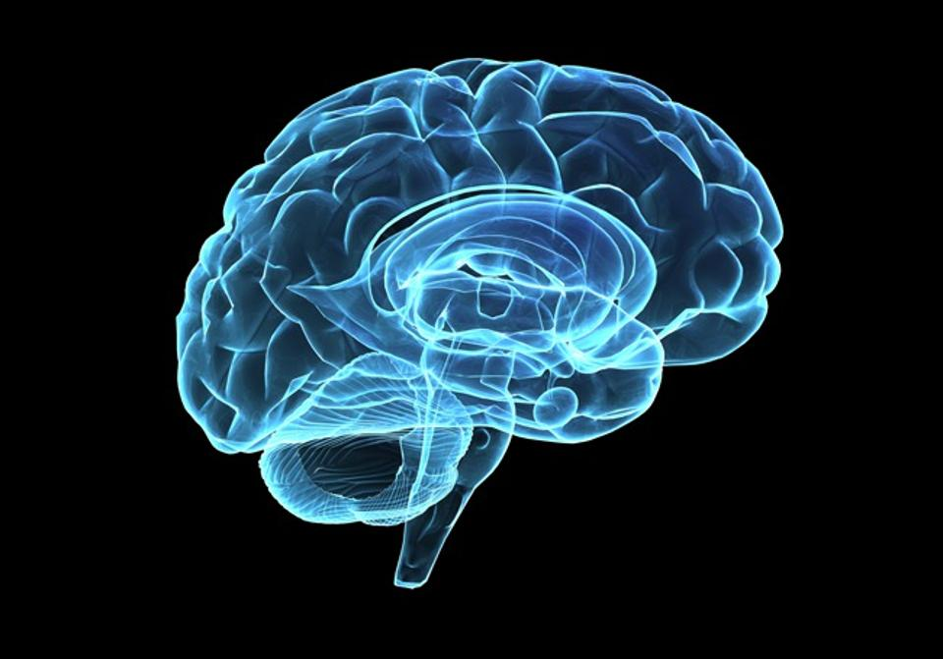
Human brain weighs 1,3 to 1,4 kilos.
Human brain is made up of 100 billion neurons.
Human brain is 80% water; the rest is fat and protein.
No two human brains are identical.
Bigger brain doesn't mean higher IQ.
There are 10 trillion pieces of information in human brain.
Messages in the brain travel at 268 kph.
Different parts of the brain perform different functions.

The left side of your brain is usually better at problem solving, maths and writing. The right side of the brain is creative and helps you to be good at art or music.
20% of body's energy is used for brain functioning.
Lack of oxygen for more than 5 minutes can cause permanent brain demage.
Interestingly, the brain can feel no pain.
When awake, human brain produces enough electricity to power a small light bulb.
Every time you yawn, you send some oxygen to the brain – this is how you cool your brain down.
You can't tickle yourself because your brain knows the difference between your touch and touch of someone else.
Regular sleep keeps your brain healthy.
Solving problems provides a 'workout' for your brain.
After a workout your brain is more receptive to learning.

Discussed with the 7th grade students

