Going hiking – important tips
May is time for some outdoorsy moments.
Check the weather before you set off on your hiking adventure.
Plan your hiking trip in advance – check some hiking guides or websites that provide information on the hiking trips.
Wear hiking shoes – avoid wearing a new pair. You can use hiking poles.
You must know what numbers to dial in case of emergency.
Your backpack should be as light as possible. Make sure you take a first-aid kit, a pocket knife, a lighter, a flashlight, a compass, a rope, some toilet supplies, a bug spray, a suntan lotion, some extra clothing, …. Take a tent and a sleeping bag in case you need it.
Make sure you pack some snacks, such as nuts or dried fruit, and some water – drinking plenty of water while hiking is important so you don't dehidrate. Hiking on empty stomach is not a good idea.
Stay on the marked trail. Don't take any detours or shortcuts because you might easily get into trouble.
Take regular breaks.
You mustn't leave litter on the trail; pack it all up in your backpack.
You mustn't touch unfamiliar plants or flowers.
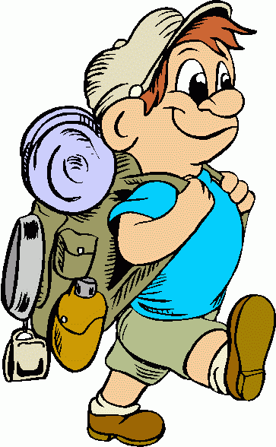
Keep in mind that we must keep quiet in the woods.
Appreciate the warmth of the sunshine, the scent of nature, the rustling sound of leaves, a view from the hill top.
- Greet people you meet.

Tips were provide by the students of Class 7.a

