Smart phones
Advantages:
You can communicate with your family, friends, coworkers, etc
You can take photos.
You can listen to music, play games.
You can use navigation or check the Google maps and don't get lost.
You can check your e-mail or check your profile in social networks.
You can search for some information any time you like.
You can use it as a flashlight or alarm clock.
You can use it as an e-book reader.
You can do some online shopping or pay the bills.
Disadvantages
You can easily get addicted to it; when we don't have it or our battery runs out we may feel completely helpless and lost.
A smart phone can consume your entire day and nothing really productive will be done.
Using a phone while driving can lead to some serious accidents.
Looking constantly at the screen surely doesn't benefit your eyes.
Using a smart phone before you go to bed will keep you awake and you will find it difficult to fall asleep.
Using a smart phone while studying will distract you.
Hackers can break into your account and steal/delete some data.
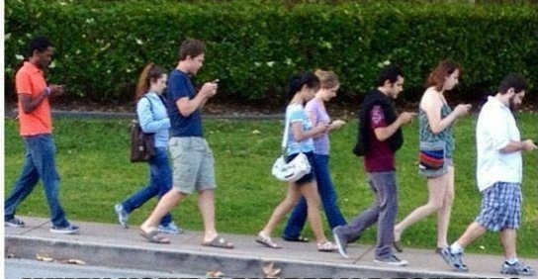
Your location can be traced and burglars can use that information to break into your house.
The costs of using a phone can be pretty steep.
Smart phones can hinder some real communication;
It seems we don't spend any quality time with the loved ones any more

Ideas of the Class 7.a

